**Guidelines for the Xampp Setup**

**Step 1: Download:**

Download the latest version of Xampp as per the windows OS

Link: https://www.apachefriends.org/download.html

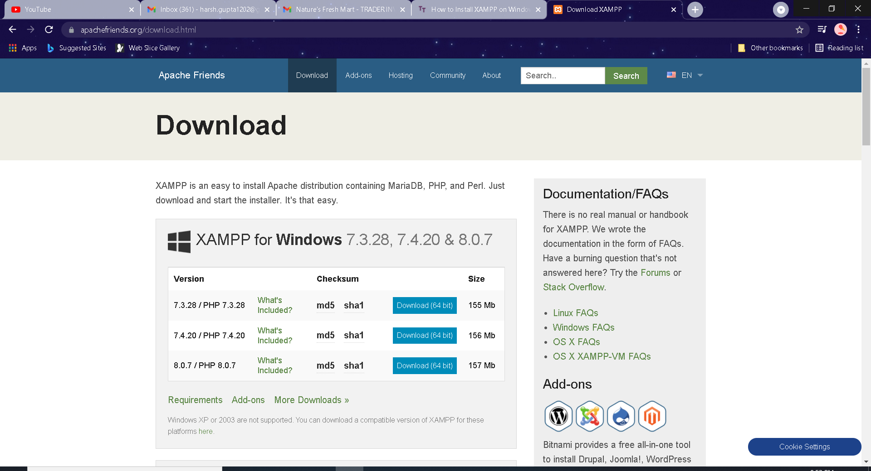

**Step 2: Run .exe file:**

After the download, run the .exe file by double clicking on the file.

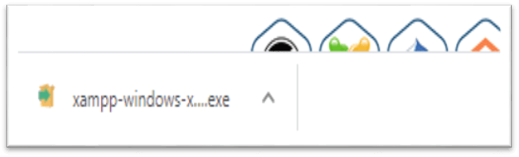

**Step 3: Start the setup wizard**

After running the .exe file then the start setup wizard will appear automatically. Then click on ‘Next’ to configure the installation.

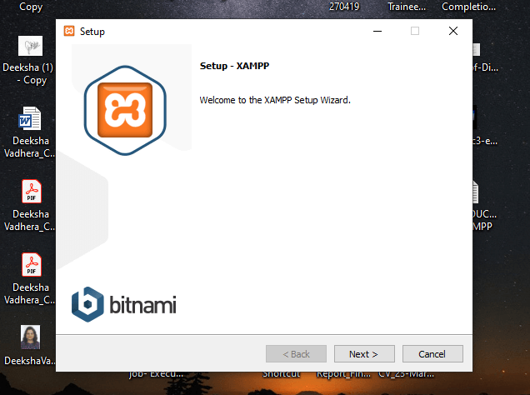

**Step 4: Choose software components.**

After clicking on the ‘Next’, then the selection of the component is available and we recommend you to install all the available component for the full services.

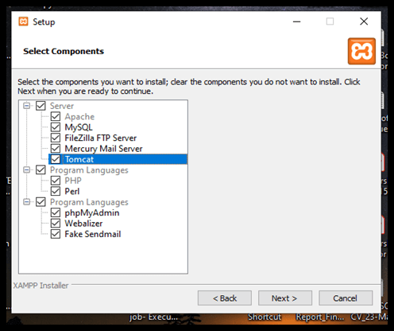

**Step 5: Choose the installation directory**

Select the directory where you are willing the installation file.

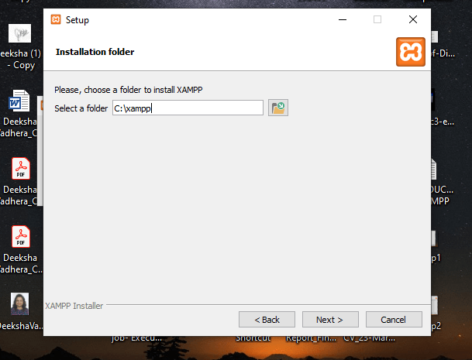

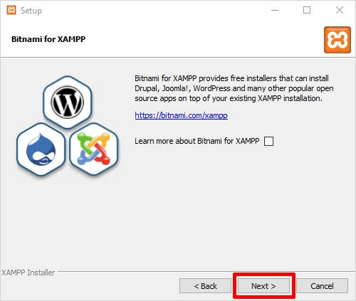

**Step 6: Start the installation process.**

The installation process is forwarded and it can take several minutes to complete.

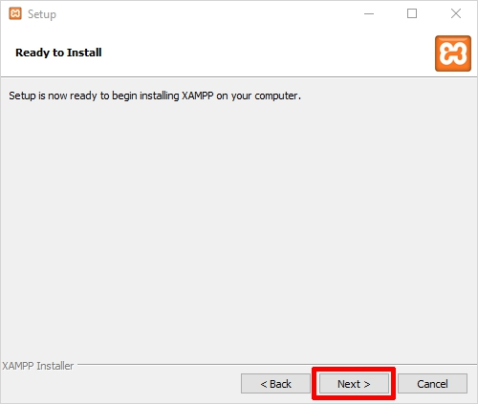

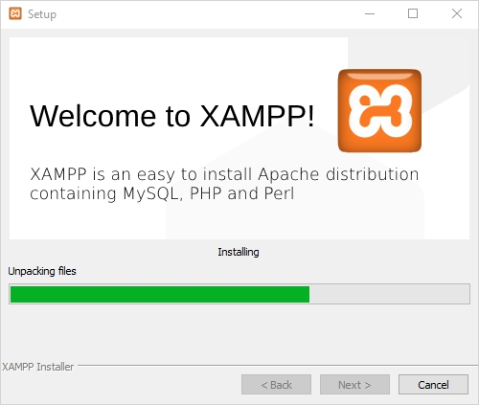

**Step 7: Complete Installation**

After unpacking all the components, the installation will be completed by clicking on the ‘Finish’ button and Xampp is good to go.

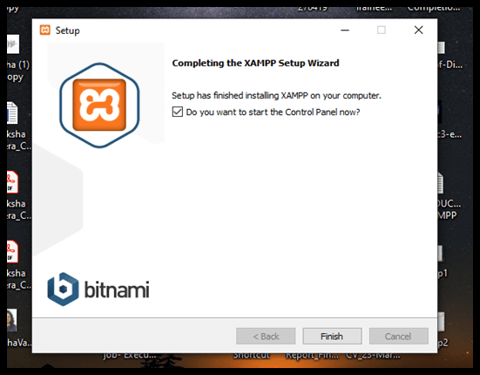

**Xampp Control Panel after all above processes have been completed**

